**Pi-rates Build guide**

First, we coded the Temperature sensor on to a spare Raspberry Pi and checked that it worked. Then we coded the screen on another spare Pi. The screen was quite difficult to code, but we managed to show a picture. Next, we coded the water flow sensor on to the pi which held the temperature sensor. When we tried to test it would just show zeros, but eventually we found out it was dividing the answer by 160 so the answer would be zero. We changed it to make sure it worked. Lastly towards the end of the project we coded the screen again to show pictures corresponding with the flow meter and the temperature sensor.

This shows how all the devices were connected:

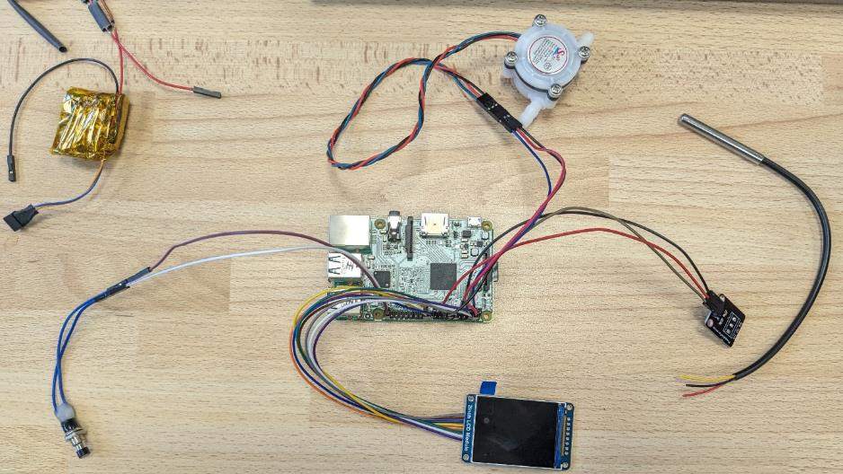

This shows where each wire connects to the Pi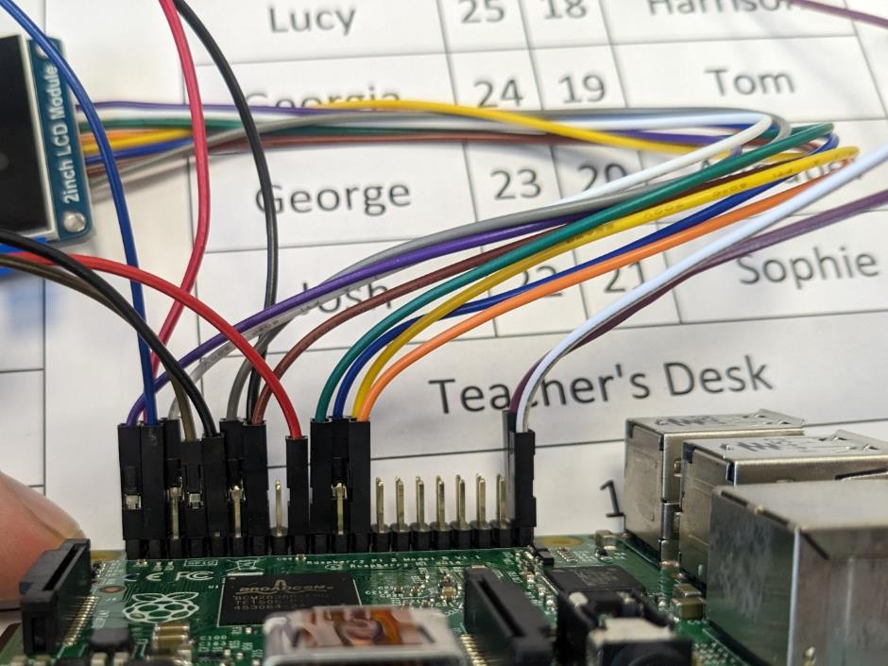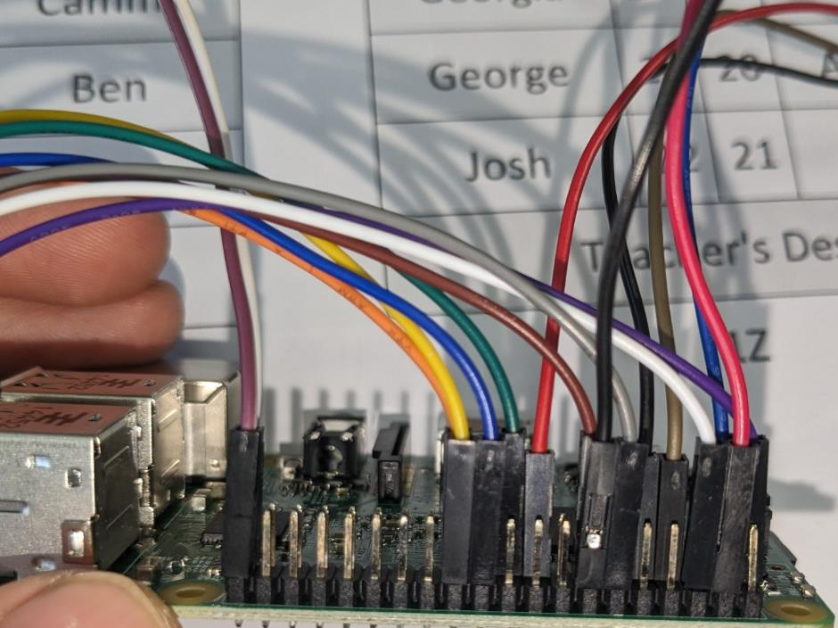

The building:

Firstly, our teacher 3D printed the outer cup model. Then once the coding had been done, he also soldered all the wires on to the mini pi. Then we fitted the pi and the wiring into the inside of the 3D printed cup.

This is how the screen connects into the cup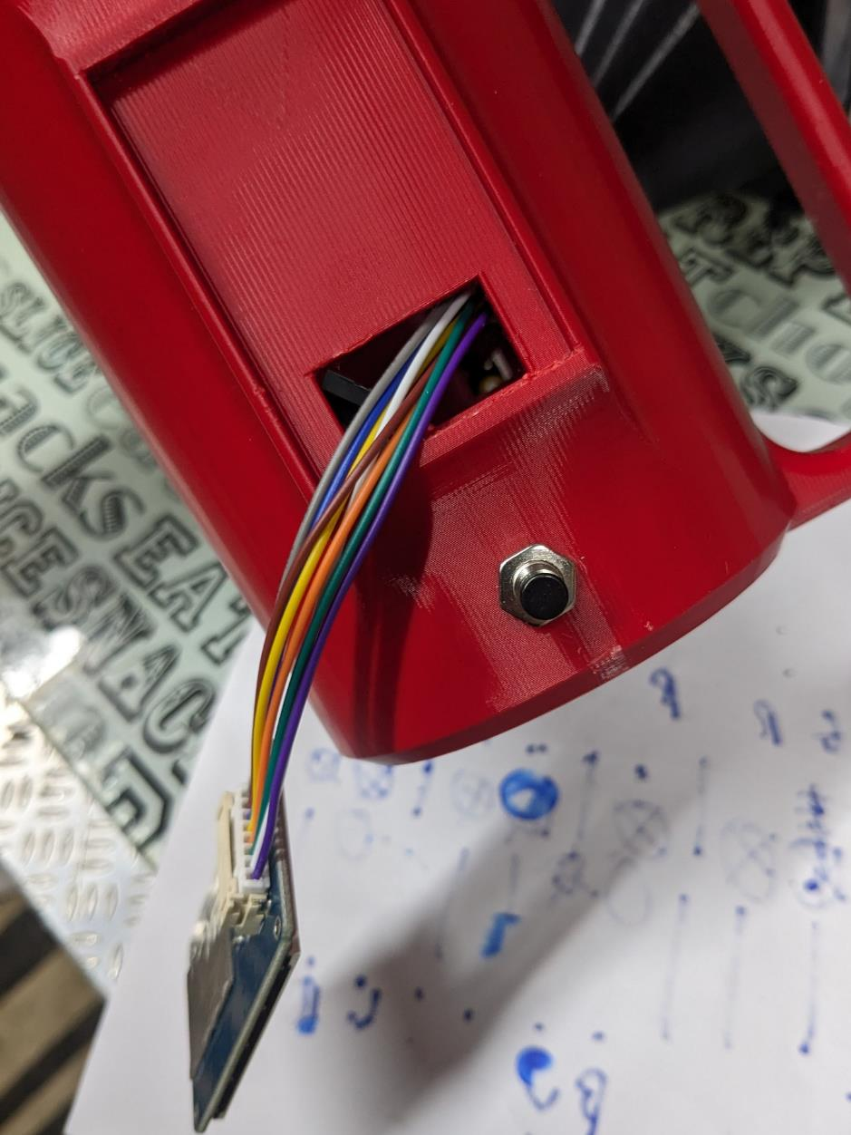

This is how the Pi Zero connects to the cup

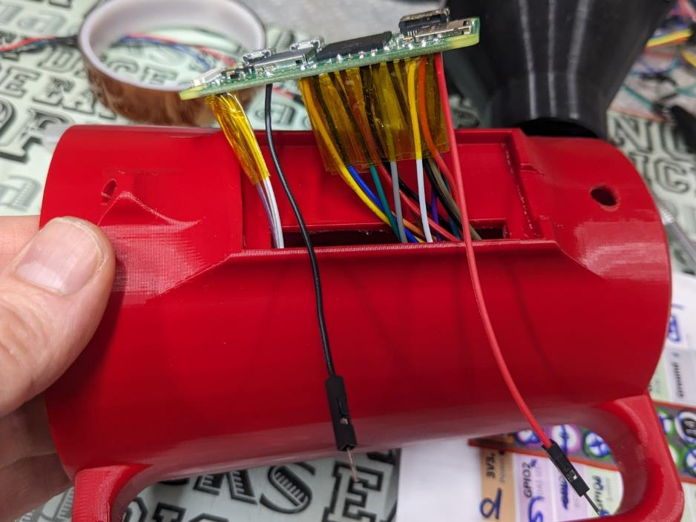

This is where the flow meter connects to the cup through the hole

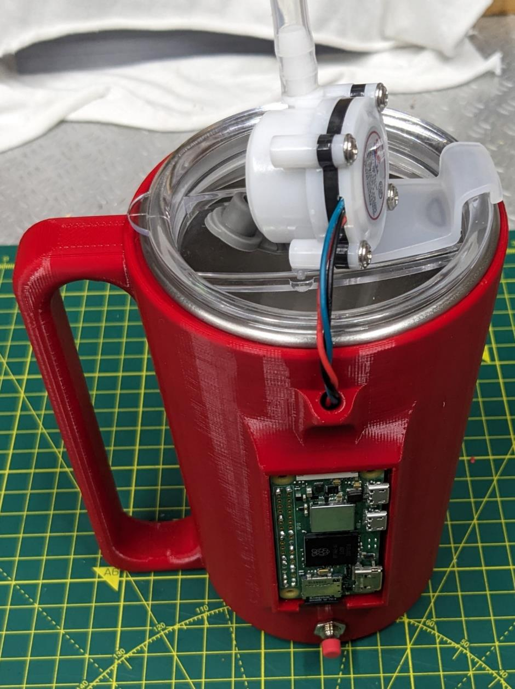

Here you can see the wiring in the cup as well as the battery and charging circuit at the bottom

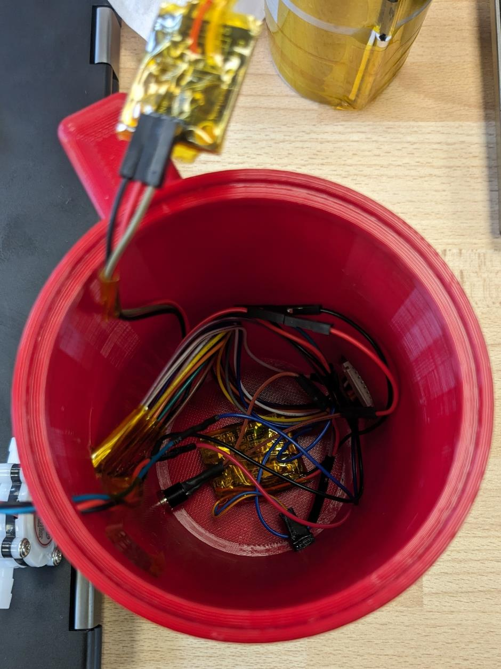

The temperature sensor was connected to the metal cup with heat conducting plaster and held in place with tape

